**Task 12 : Write Terraform script to create highly available infrastructure in AWS. The infra should have1 vpc, 3 subnets setup in 3 different az and 2 instances setup in 2 different subnets**

**Creating Terraform script :**

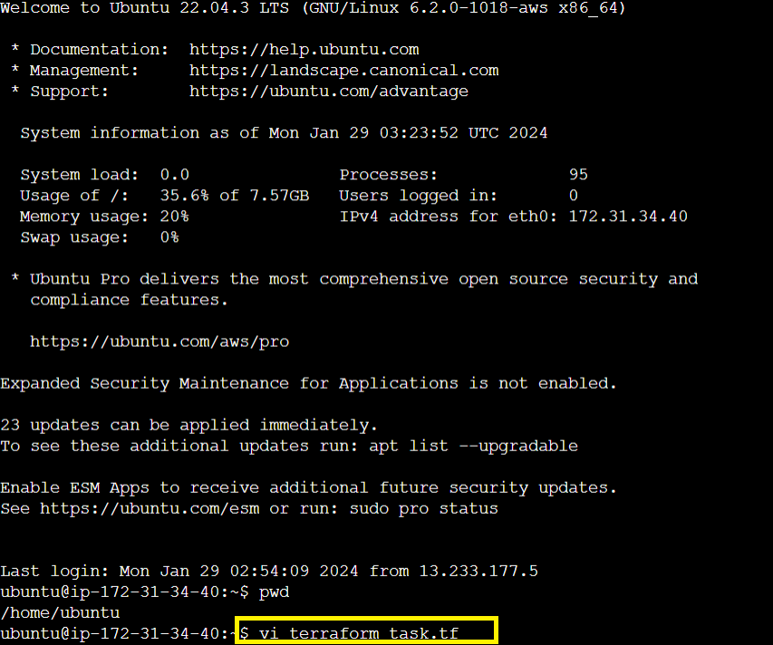

1. **Creating 1 VPC :**

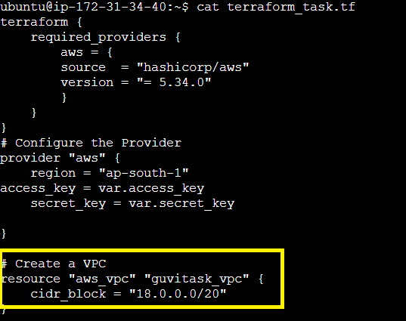

1. **Creating 3 subnets under the VPC :**

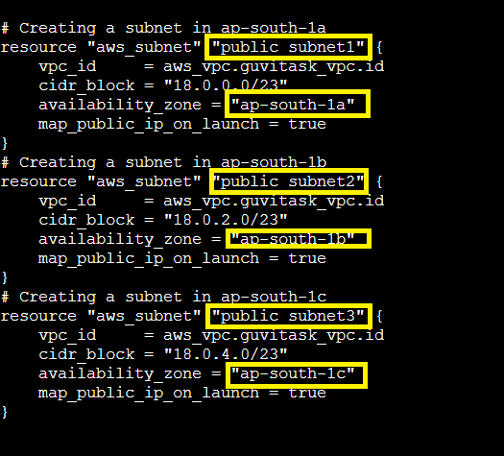

1. **Creating Internet Gateway and 2 instances:**

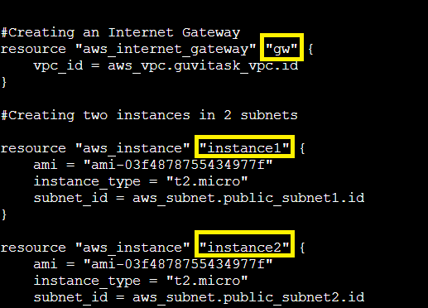

1. **Declaring the variables :**

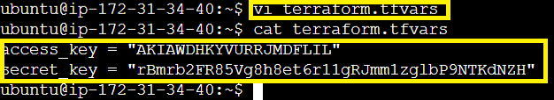

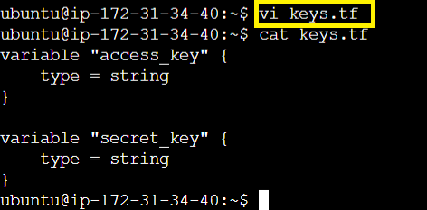

**Initiating Terraform :**

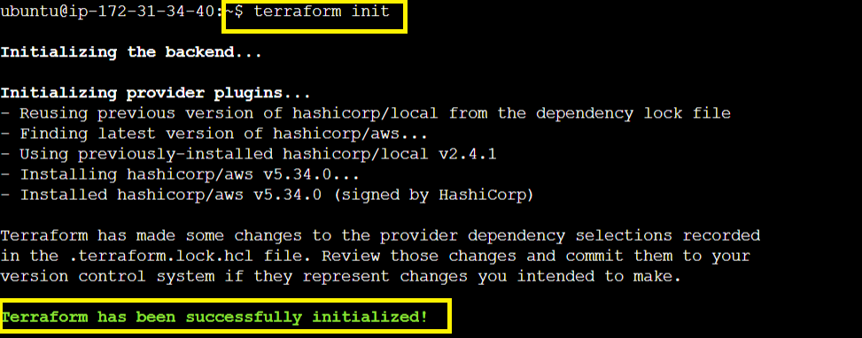

**Planning Terraform :** 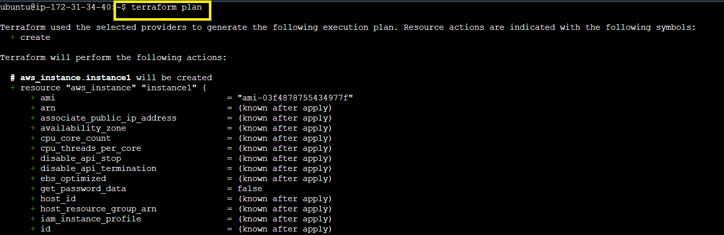

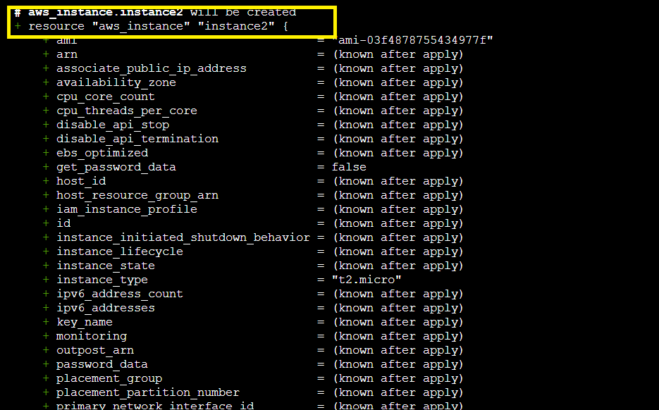

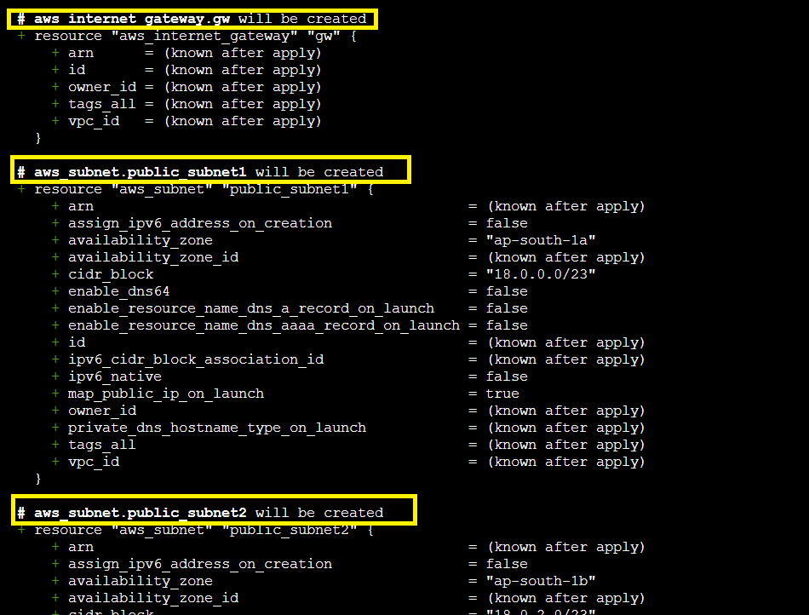

**Terraform Apply**

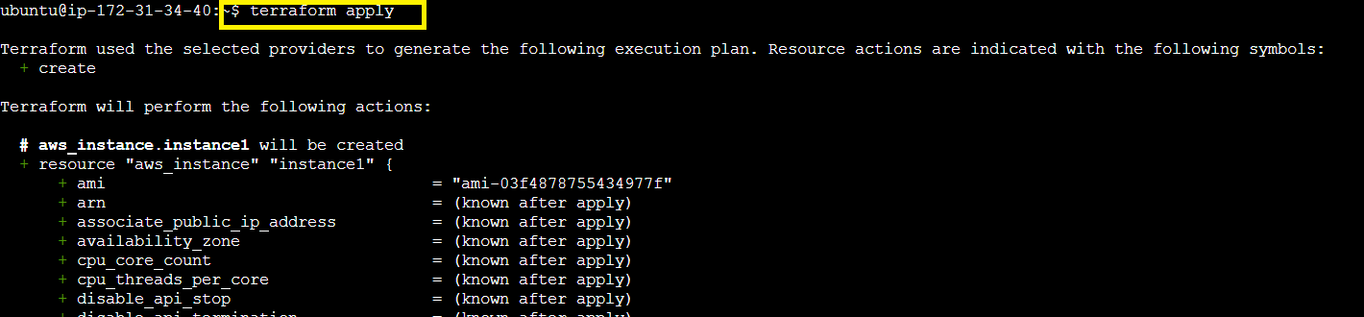

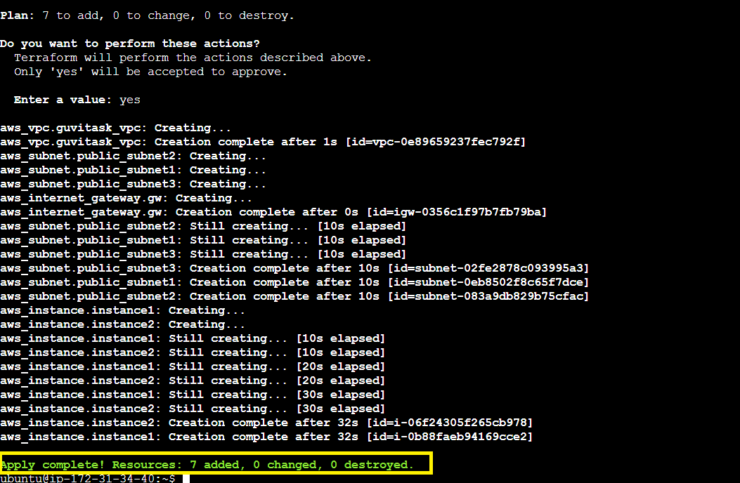

**Checking on AWS console for the newly created resources :**

**VPC :**

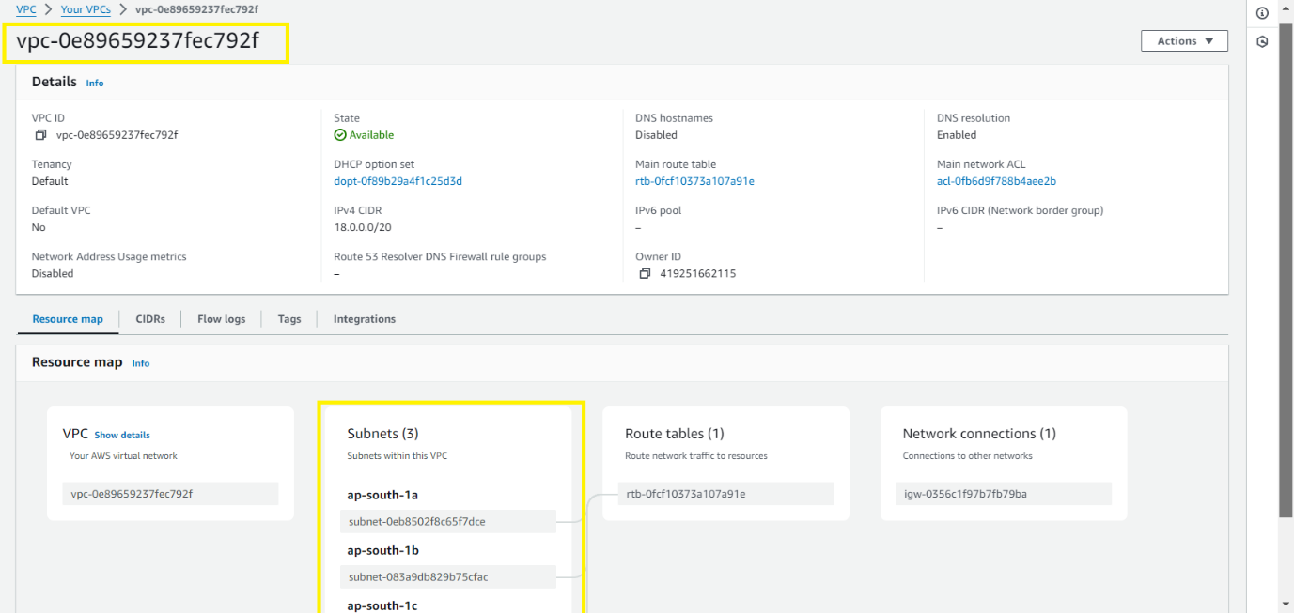

**Subnets :**

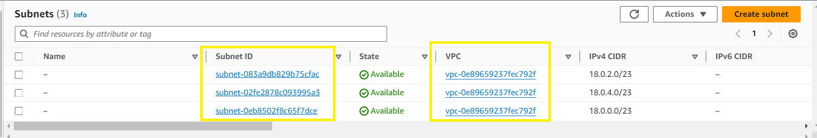

**Internet Gateway :**

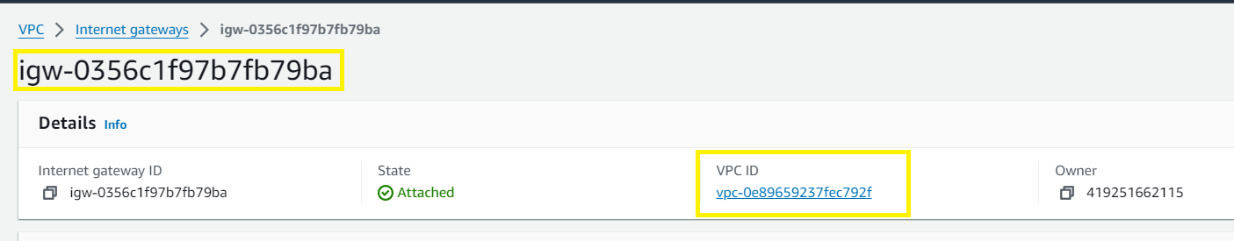

**Instances :**

